 | Project Pittawella
4/19/2016 | Financial Agreements and Governance
 | This document contains the financial agreements between Boost Foundation and FutureCare for the Project Pittawella. This Document is an official contract and part of the partner agreement (partnerovereenkomst) Also the governance is described which consist of the meetings, reporting and overall progress management.

Project Pittawella
Financial Agreements and Governance

Payment Details
Name of NGO | FutureCare
Founder and Director | Ramani Smits
Legal Entity | No
Address | 210/1a, pleasant view, Mount Pleasant Garden, Bowalawatha, Kandy, Sri Lanka
Telephone | +94777860663
Website | www.futurecarelk.com
Email | futurcare@gmail.com
Bank Details | R.V. Smits  Commercial Bank of Ceylon, Branch Kandy  8150902086  Swift Code CCEYLKLxxxx

Payment Plan
The scheduled payments are shown in the table below. Each payment corresponds to an activity that can be seen in the project plan and budget table. Deviation of the destination must be discussed in the bimonthly.
Scheduled pay Date | Amount | Project Code
1-5-2016 | €1500,- | 311, 510, 610, (313, 513, 613 advance workers)
15-6-2016 | €2000,- | 313, 513, 613, 410, 413, 710 (713)
15-7-2016 | €3000,- | 910,1010, 810, 813, 713, (313, 513, 613, 413 final)
Total | €6500,-

Boost Foundation provides project management, volunteers and the budget of €6500,-, so that FutureCare can renovate Pittawella Primary School and support children

Ground Rules
For all money received Futurecare will provide a detailed overview of bank statements.
FutureCare will spend money according to the pre-defined product codes and report according to the project Governance.
For all money spent Futurecare will collect evidence of expenditure in the form of:
- receipts from local vendors;
- signed Vouchers from local workers (see attached vouchers);
- photographic evidence of bought materials;
- and photographic evidence of completed items (with corresponding product code).
- FutureCare notes the sprint name on the receipt, bill or voucher.
All of the above can be photographed and emailed to foundationboost@gmail.com. With Pittawella in the description.

Project Phases and Finance

Project steps
An overview of the items (000-1100) are described in the picture below. Each Sprint (300-1000) corresponds to a work package and can be initiated at any given time during the project.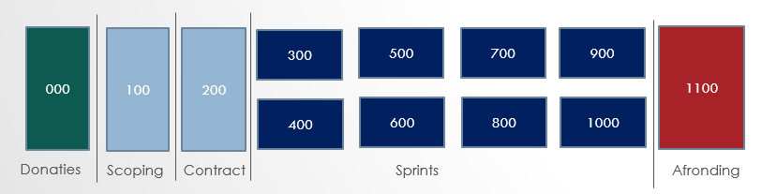

timeline

Phase | Date | Duration | Governance
Initiation | 15th -31st April 2016 | 2 weeks | Ian Upton initiates project
Sprint | 1st May – 1st October | 5 Months | Futurecare leads project.  Ramani Reports bimonthly to boost board. Volunteer reports on progress in July
Closing | 1st October | 2 weeks | Board member gathers information for final report and evaluation.

Budget

The cost components are summarized in the table below along with the budget:
Item | Product Code | Budget
Water Facilities | 300 | € 500,-
Toilets | 400 | € 750,-
Entrance to school | 500 | € 1500,-
Staircase | 600 | € 1000,-
Library | 700 | € 500,-
Playground | 800 | € 1000,-
School Materials for Kids | 900 | € 750,-
Lesson Materials for Teaching | 1000 | € 500,-
 | Totaal | € 6500

Project Governance
Good project governance, communication and reporting is an essential and mandatory part of the project. The level of governance often defines the success or failure of a project.

Meetings
The meetings will be documented and all reports and minutes will be uploaded to the Boost Foundation website. It is important to maintain our core values (honesty and transparency) and report on good and bad results. This way we can learn from our mistakes.
Every two weeks a project meeting will be held discussing the following topics:
- Good News – Boost Foundation and FutureCare discuss any news that is good
- Bottlenecks – Any problems that FutureCare or Boost has ran into in the past weeks or foresees
- Project Status – The Project report will be updated and uploaded to the website
- Financials – All of the spending will be discussed and updated to the website
Starting Saturday the 21st of may at 20:00 Sri Lankan time. Each meeting will last approximately 30-45 minutes. The following people will attend.
Futurecare | Boost Foundation
Ramani Smits  Sameera Bandara | Justin Sloove (Ian Upton)  Remco Scherpenzeel (Roderick Loodewijks)

Other Communication
During the duration of the project we will send a volunteer to report on the progress and write a newsletter. She will be interviewing the local people and workers to see if everyone is happy. This newsletter we will publish and make available to our sponsors. On completion of various sprints we will report the progress on Facebook and other social media.

evaluation
The final evaluation and closing report will be carried out by board members of Boost foundation together with FutureCare.

Boost Foundation

Boost Foundation was founded in January 2016 by a group of professionals that want to change the world for the better. What we stand for is summarized below in our strategic one pager.

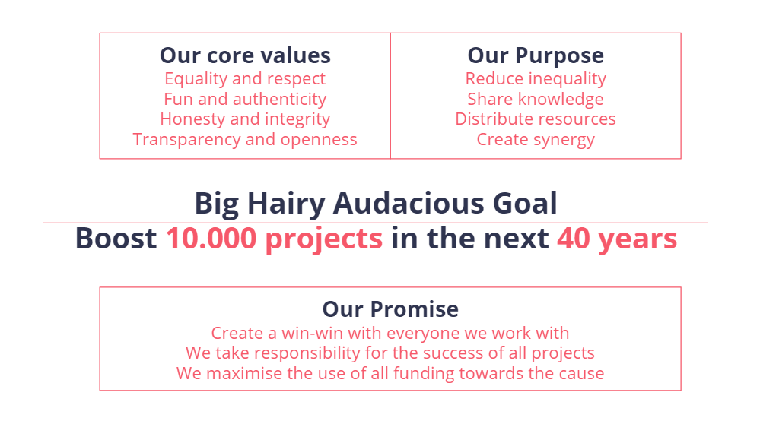

Legal information

KvK number: ​65559975

RSIN/fiscaal number: 856162000
​IBAN: NL52 INGB 0007 2864 03

Contactinformation:
Stichting Boost Foundation
t.a.v. Secretaris Erudini Smits
Wagenaarstraat 16
NL-1601 LH Enkhuizen
T: +31681463975
​E: foundationboost@gmail.com
W: www.boostfoundation.eu

Signed in threefold

Namens FutureCare

Naam Ramani V. Smits Datum
Functie Bedrijfsleider Plaats Kandy

Namens Stichting Boost Foundation.

Naam Ian Upton Datum
Functie Voorzitter Plaats Kandy

Namens Stichting Boost Foundation.

Naam Justin Sloove Datum
Functie Penningmeester Plaats ’s-Hertogenbosch

