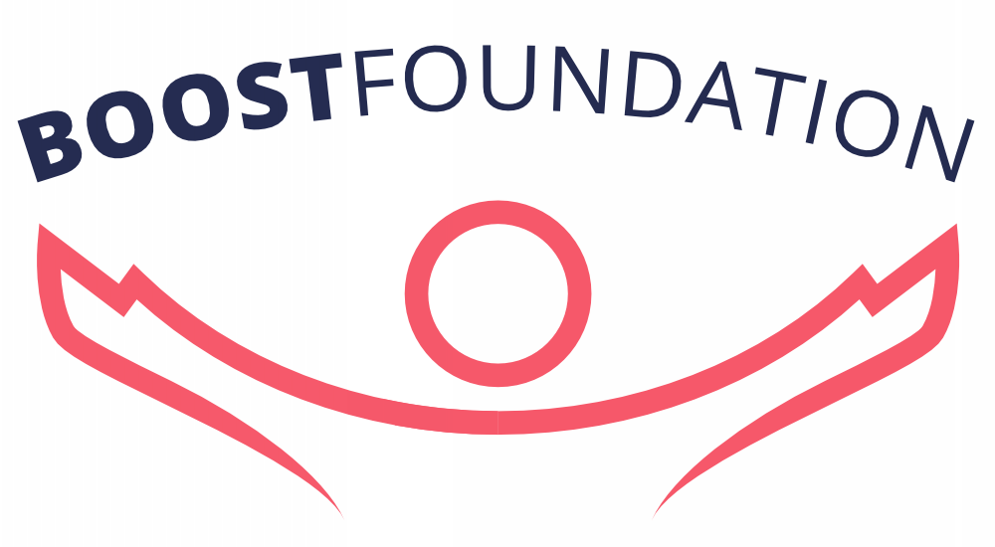

Together we change the world

Volunteer Policy
Version: 1
Author: Roderick Lodewijks, Erudini Smits, Salomé van der Giessen
Status: Installed
Date: 10-02-2016

TABLE OF CONTENT

Introduction
1. Values
1.1 Values for entire organisation
1.2 Volunteer appreciation
1.3 Volunteer recognition
1.4 Win win situation
1.5 Volunteer equality
2. Preparation and planning
2.1 Volunteer involvement
2.2 Volunteer involvement in disputes
2.3 Role description
2.4 Volunteer insurance
2.4.1 Volunteers in the Netherlands
2.4.2 Volunteers working abroad
2.5 Reimbursement of expenses
2.6 Provision of resources
2.7 Volunteer involvement responsibility
2.7.1 Overall volunteer responsibility
2.7.2 Volunteer performance responsibility
2.8 Day-to-day support
2.9 Provision of initial information
3. Recruitment and selection
3.1 Approach to volunteer recruitment
3.2 Volunteer selection procedure
4. Management of volunteers
4.1 Volunteer Agreement
4.2 Induction procedure
4.3 Settling in period
4.4 Support and supervision
4.5 Volunteer training
4.6 Deal with difficulties
4.7 Volunteer information & interactivity
4.8 Monitoring volunteers
4.9 Intellectual property
Definitions
Level 1 volunteers
Level 2 volunteers

Introduction

In the volunteer policy, the Executive Board of the Boost Foundation determines the current volunteer policy. This policy was adopted in the board meeting of February 7, 2016. The policy will be revised annually if necessary.

1. Values
In this section we lay out some ground values that are applicable to all volunteers that are affiliated to the Boost Foundation.

1.1 Values for entire organisation
These values are: equality/respect, authenticity/fun, honesty/integrity, transparency/openness. We expect each person involved to respect these values.

1.2 Volunteer appreciation
Boost Foundation appreciates the commitment of the volunteers, because we are able to achieve our goals due to the time and attention they give us. We appreciate everyone's efforts.

1.3 Volunteer recognition
Boost Foundation recognizes volunteers as part of the core of the organization.

1.4 Win win situation
Boost Foundation benefits from the skills, experience and enthusiasm of volunteers. We believe that volunteers should be able to gain personal benefits from the experience too. We are committed to managing volunteers in a way that ensures that the needs of both parties are met.

1.5 Volunteer equality
Boost Foundation strives to create a diverse organisation with equal opportunities. Therefore, we are committed to ensuring equality of access to high quality volunteer opportunities and equality of treatment for our volunteers in all our policies and practices.

2. Preparation and planning

In this area we address those actions and systems that need to be put in place to agree on the nature and purpose of volunteer involvement.

2.1 Volunteer involvement
Boost identifies roles for volunteers which extend the work of the organisation. Volunteers are involved at every level of the organisation, except the strategic level on which the board operates.

2.2 Volunteer involvement in disputes
Volunteers will not be used in times of disputes to do the work of the board. They may continue with their regular tasks, but will not be asked to undertake additional duties.

2.3 Role description
Volunteers are provided with a written role description, outlining the purpose, tasks, main expectations and authorizations of their role. This role is reviewed at least once a year with the volunteer's supervisor.

2.4 Volunteer insurance

2.4.1 Volunteers in the Netherlands
Boost volunteers in the Netherlands are protected by Boost Foundation's public liability insurance and their personal accident insurance. Drivers using their cars in connection with their voluntary work must inform their own insurance company to ensure adequate and continued cover.

2.4.2 Volunteers working abroad
Volunteers working abroad are not insured by Boost Foundation. We will advise these volunteers about possible insurances to assure their safety.

2.5 Reimbursement of expenses
Boost Foundation does not reimburse volunteers' out of pocket expenses for travel.

2.6 Provision of resources
Boost Foundation endeavours to provide adequate and appropriate facilities, equipment and resources to enable volunteers to fulfil their roles. Nevertheless volunteers will be asked to use their own resources in the process.

2.7 Volunteer involvement responsibility

2.7.1 Overall volunteer responsibility
The CHRO is responsible for the overall management of the volunteers involvement, including volunteer wellbeing, overseeing the implementation of this policy, and dealing with major disputes relating to volunteers. (The volunteer’s supervisor handles minor disputes. Look at point 4.6 of this document for a more detailed view of the dispute policy.)

2.7.2 Volunteer performance responsibility
- The COO is responsible for the performance of volunteers working on Projects, internal and abroad.
- The CFO is responsible for the performance of volunteers working on Finance & IT.
- The CCO (Communications) is responsible for the performance of volunteers working on Marketing & Communications.
- The CCO (Commercial) is responsible for the performance of volunteers working on Corporate Fundraising.
- The CHRO is responsible for the performance of volunteers working on Human Resources.

2.8 Day-to-day support
The volunteer's designated supervisor provides support and supervision, guides the volunteer’s tasks and results, and identifies training requirements.

2.9 Provision of initial information
Upon showing interest in getting involved with Boost Foundation volunteers will be provided with general informative guides and policies. Upon showing interest in a particular role they will also receive all guides and policies that are relevant to the aspired position. When volunteers apply for a role they will be asked to sign some of these documents

3. Recruitment and selection
We aim to provide a fair, effective and transparent process of attracting and selecting volunteers. In this section we lay down the minimum requirements for consistent implementation of volunteer recruitment and selection.

3.1 Approach to volunteer recruitment
Boost Foundation is committed to serving and representing all the people of the world and wishes to see people of all ethnicities represented among our volunteers. Volunteer opportunities are widely promoted on the Internet, and we strive to make recruitment and selection materials available and accessible to any individual or group upon request.

3.2 Volunteer selection procedure
Boost Foundation implements a fair, effective and open system in the recruitment and selection of volunteers and treats all information collected in this process confidentially. All potential volunteers will go through the Volunteer Proceedings; a recruitment and selection process that is appropriate to the role offered. Boost Foundation uses registration forms and interviews to make their decision. Additional measures may be implemented depending on the nature of the volunteers role. A ‘declaration of good behaviour’ may be asked where appropriate. The process is conducted by appropriately briefed/trained staff and aims to allow both parties to give and receive sufficient information to assess whether the volunteer opportunities available match the potential volunteer's skills, qualities and interests. If unsuccessful, individuals will be offered an opportunity to discuss the outcome and identify possible alternatives within or outside Boost Foundation.

4. Management of volunteers

This section specifies how we intend to manage volunteers once they have become involved. Goodwill alone is not enough to guarantee success. A proactive approach is essential to achieve the organisation's and volunteer’s objectives.

4.1 Volunteer Agreement
Only level 2 volunteers are provided with a Volunteer Agreement, which outlines the expectations and responsibilities of both the volunteer and Boost Foundation. This agreement may be reviewed at any time with the consent of the volunteer and his/her supervisor, including during the review meeting at the end of the settling in period (see point 4.3).

4.2 Induction procedure
All volunteers are provided with an induction within six weeks of commencing their voluntary work. The induction: provides background information on Boost Foundation; explains its structures and procedures; describes the volunteer role and the work team and outlines how s/he will be supported, including practical information. During the induction period volunteers will be provided with written information on relevant legislation, organisational policies and codes of practice and will be given the opportunity to discuss any of the issues with their supervisor and/or the CHRO. Prior to going abroad level 2 volunteers will be introduced to their local contact.

4.3 Settling in period
Level 2 volunteers are subject to a settling in period, the length of which depends on the nature and hours of the voluntary work. During this period volunteers are given additional support and a review meeting between the volunteer and his/her supervisor is held at the end of the settling in period to ensure that all parties are satisfied with the arrangement.

4.4 Support and supervision
All volunteers are allocated a supervisor. This person can provide day-to-day help and guidance on any issue related to the voluntary work and is responsible for providing regular support to, and supervision of, the volunteer. The frequency, duration and format of this support and supervision is agreed between the volunteer and his/her supervisor at the end of the settling in period.

4.5 Volunteer training
Boost Foundation is committed to improving the effectiveness of volunteers. Volunteers may choose to attend any in-house training course that they feel is relevant to their voluntary work, subject to the approval of their supervisors and availability. Boost Foundation does not reimburse external courses. Volunteers attending approved internal training courses may do so within their normal hours of voluntary work.

4.6 Deal with difficulties
Boost Foundation aims to reflect the voluntary nature of our relationship with volunteers in all our policies and procedures for managing their involvement. Therefore, the volunteer's designated supervisor deals with minor complaints or grievances about or by volunteers or their work through the usual support and supervision procedures, in the first instance. However, we recognise our duty to protect the wellbeing and interests of all our stakeholders and therefore operate a formal complaints procedure in the case of more serious complaints. In the case of particularly serious offences, as specified in the Code of Conduct (Huisregelement), this process may be bypassed and/or the subject of the complaint asked to leave. Where a criminal offence is suspected, the matter will be handed over to the police.

4.7 Volunteer information & interactivity
Boost Foundation recognises the core role that volunteers fulfil at every level of the organisation. Therefore we aim to communicate with volunteers in many ways. Feedback from volunteers is always welcome and any volunteer may make representations to the monthly meeting of the Executive Board.

4.8 Monitoring volunteers
In order to effectively monitor the work that volunteers do and how they are managed, a personal file is maintained for all volunteers, which includes: contact details and other relevant personal information; details of the application and selection process; agreements made; hours worked; records of support and supervision activities; training undertaken and any complaints or grievances made or received. Some of this information and other relevant information may also be recorded in computerised records. All such information is treated in accordance with the Dutch Privacy Law.

4.9 Intellectual property
Boost Foundation and the volunteers agree that the intellectual property rights of original work produced by volunteers automatically transfers to the organisation.

Definitions

Level 1 volunteers
Level 1 volunteers are Low Risk Volunteers. They will not visit a project and will not meet any children, or other people needing help. They will primarily have tasks that are related to the performance of Boost Foundation itself.

Level 2 volunteers
Level 2 volunteers are High Risk Volunteers. They are authorized to visit a project, meet children, and other people needing help. They will primarily have tasks that are related to projects.

