Minutes for Boost Foundation

03-09-2017 (13:30 in Rotterdam)

Call to Order
The 21st monthly meeting of Boost Foundation was held on 03-09-2017 in Rotterdam at AAAFresh123. It began at 13:30 and was presided over by Ian Upton.

Attendees
Voting members in attendance: Ian Upton and Remco Scherpenzeel.
Non-voting members in attendance: Marc René.
Voting members that were absent: Erudini Smits, Justin Sloove, Osman Akin, Roderick Lodewijks and Henk Bethlehem.
Non-voting members absent: Gert-Jan ter Schure.

Proceedings
Theme
Small monthly. Lot of people are absent because of other responsibilities. We just had a small discussion and a workgroup session.
Extra discussion points:
Focus on core activities
We made a small overview on our core activities:
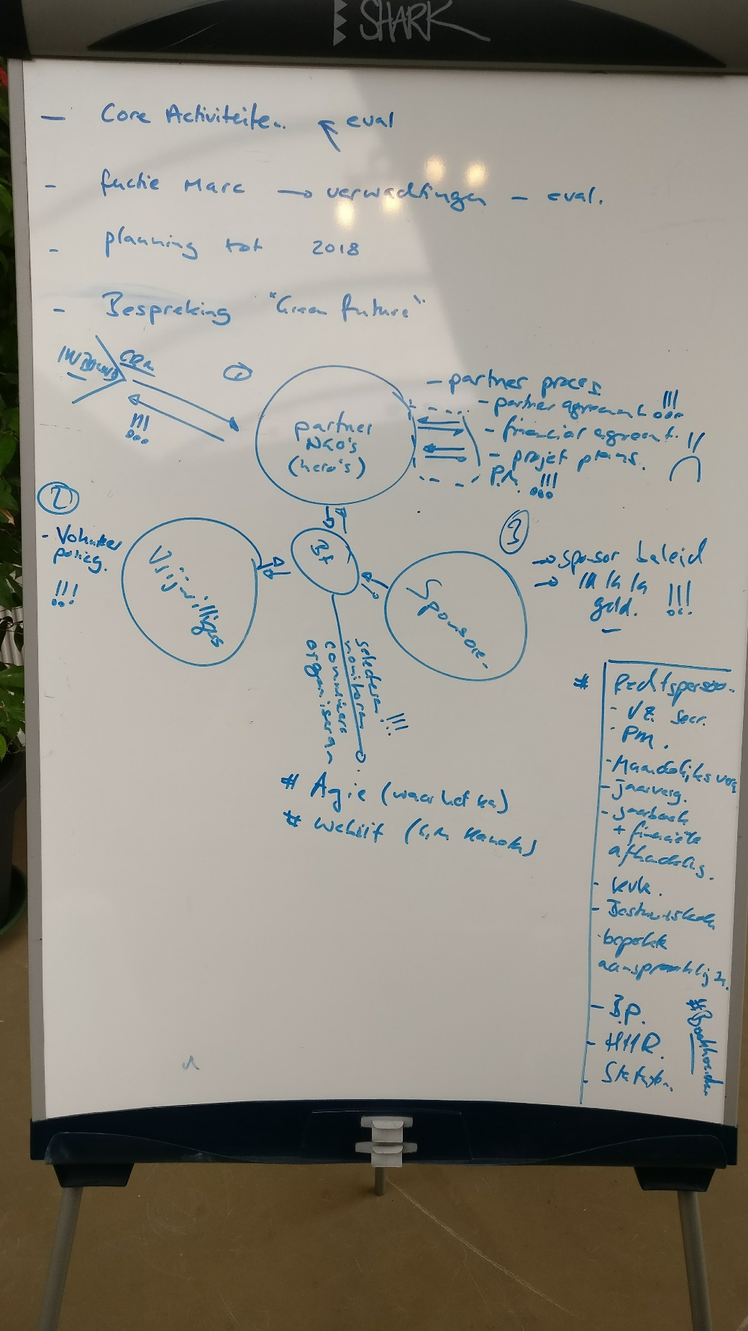
Ian agreed that he will chart our current core processes.

Results from workgroup session:
- Remco: Created tasks to follow up deals in HubSpot. Please complete your tasks before next weekly. Didn’t do Roderick’s deals because he is on holiday. Also removed the “Just-in Time” deal. It was a test deal, but people where mistaking it for the OGD deal. Moved all relevant info to the OGD deal.
- Ian and Marc: Setup a separate pipeline for projects in HubSpot.
- All: Discussed about IT so Marc can continue the setup of and implement our strategy with Gert-Jan.

Adjournment
Ian moved that the meeting be adjourned, and this was agreed upon at 17:30.
Remco Scherpenzeel |  | 03/09/2017
Vice-Secretary Boost Foundation |  | Date of Approval  06/09/2017

